**Course: C339 Data Fundamentals**

**Date: February 22, 2023**

**Title: Reduction of ERDs to tables and clauses in SQL.**

**Reduction of ERDs to tables**

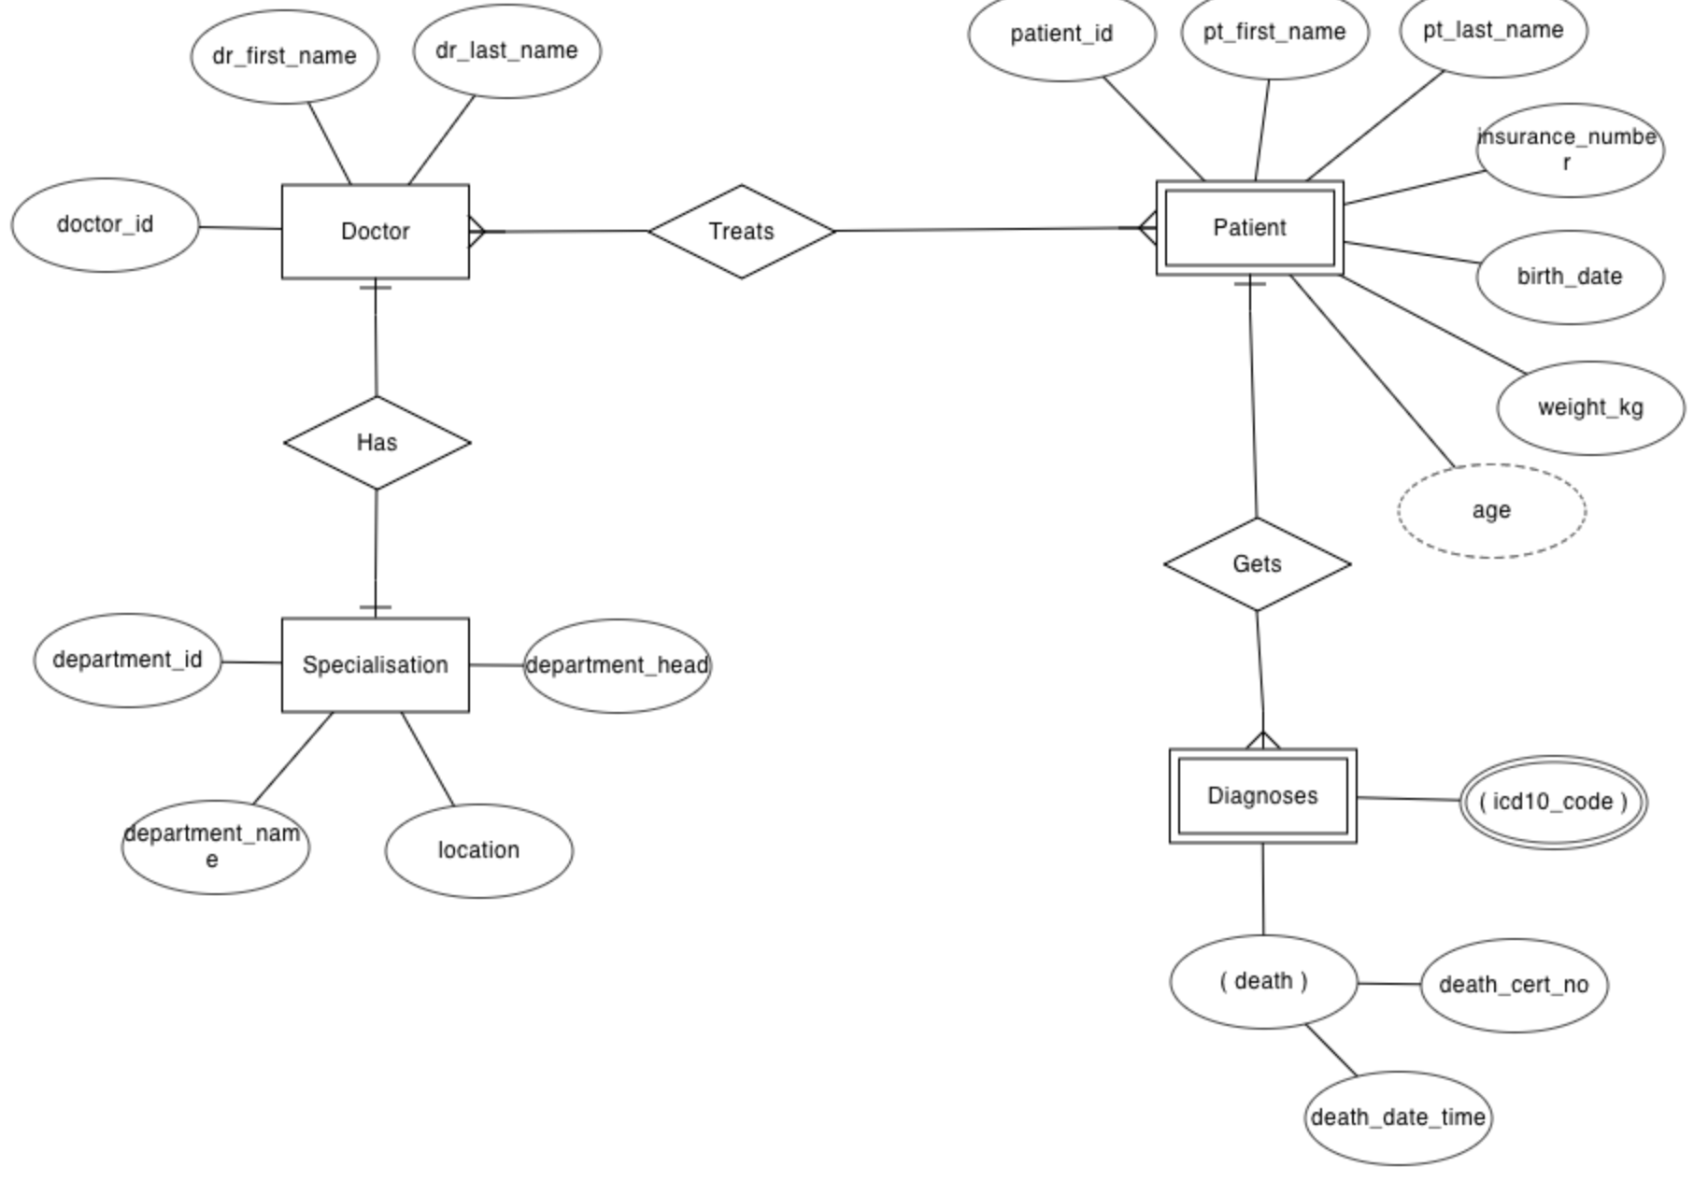

Figure 1: ERD of doctor, patient, diagnoses, and specialisation.

The database can be represented using the notations, and these notations can be reduced to a collection of tables. In the database, every entity set or relationship set can be represented in tabular form. There are some points for converting the ER diagram to the table:

1. Entity type becomes a table.
   * Doctor, Specialisation, Patient, and Diagnoses form individual tables.
2. All single-valued attributes become a column for the table.
   * doctor_id, dr_first_name, and dr_last_name forms columns of the Doctor table.
3. A key attribute of the entity type represented by the primary key.
   * doctor_id, department_id, patient_id are the key attributes of the entity.
4. The multivalued attribute is represented by a separate table.
   * In the diagnoses table (Example 2), icd10_code is a multivalued attribute. Therefore, it is not possible to represent multiple values in a single column of the diagnoses table.
   * Hence, we create a table diagnoses_icd10 with column name patient_id and icd10_code. Using both columns, we create a composite key.
5. Derived attributes are not considered in the table.

Hence, from Figure 1 we can draw a figure in table form as below.

[Insert table form here]

**SQL clauses**

A clause in SQL is a built-in function that helps to fetch or access the required records from the database table.

| **Clause** | **Description** |
| --- | --- |
| HAVING | HAVING clause can be used in a GROUP BY clause. It is used to specify a search condition for a group in the database tables |
| WHERE | The WHERE clause in SQL is used to retrieve the specific data from the database that specifies the conditions exactly that are given in the UPDATE, DELETE, etc statements. |
| ORDER BY | The ORDER BY clause in SQL is used for sorting the records of the database tables. |
| GROUP BY | To group the result set of the rows that have the same values in the result set from the database tables, the GROUP BY clause is used. |
| TOP | This clause is used when the database has a large number of records. It is used to specify the total number of records to be fetched or returned. |
| WITH | WITH clause acts as a temporary view as it is available only during the execution of SELECT, UPDATE, INSERT, DELETE, etc. statements. It is used to simplify the complex and long queries. |
| LIKE | The SQL LIKE clause is used to compare a value to similar values with the use of wildcard operators i.e. percent sign ( % ) and the underscore operator ( _ ). |
| FROM | The FROM clause in SQL is used to select the database tables which are manipulated using the SELECT, DELETE, and UPDATE statements. |
| LIMIT | The LIMIT clause is used when you are dealing with the large databases. It is used to specify the maximum number of rows to be retrieved from the table. |
| AND | The AND clause is used when multiple conditions are specified in a query and returns a dataset when all the conditions given in the AND clause meet the requirements. |
| OR | The OR clause is used when multiple conditions are specified in a query and returns a dataset when one of those conditions gets satisfied. |
| ANY | https://www.sqltutorial.org/sql-any/ |

Examples listed here

<https://docs.oracle.com/javadb/10.6.2.1/ref/rrefclauses.html>

**SQL Order Execution**

For readability clauses are interpreted from left to right, but SQL executes them usually in a different order.

The order in which the clauses in queries are executed is as follows:

1. FROM/JOIN: The FROM and/or JOIN clauses are executed first to determine the data of interest.

2. WHERE: The WHERE clause is executed to filter out records that do not meet the constraints.

3. GROUP BY: The GROUP BY clause is executed to group the data based on the values in one or more columns.

4. HAVING: The HAVING clause is executed to remove the created grouped records that don’t meet the constraints.

5. SELECT: The SELECT clause is executed to derive all desired columns and expressions.

6. ORDER BY: The ORDER BY clause is executed to sort the derived values in ascending or descending order.

7. LIMIT/OFFSET: Finally, the LIMIT and/or OFFSET clauses are executed to keep or skip a specified number of rows.